- What do you and your pet like to do together? (circle all that apply)

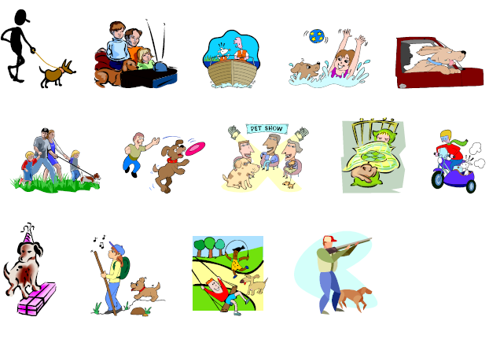

- Which picture is most like your dog? (circle one)

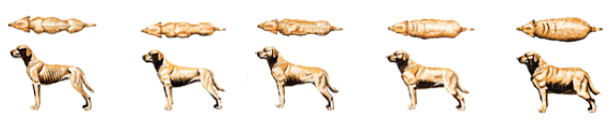

3. What is your pet’s age in human years?

