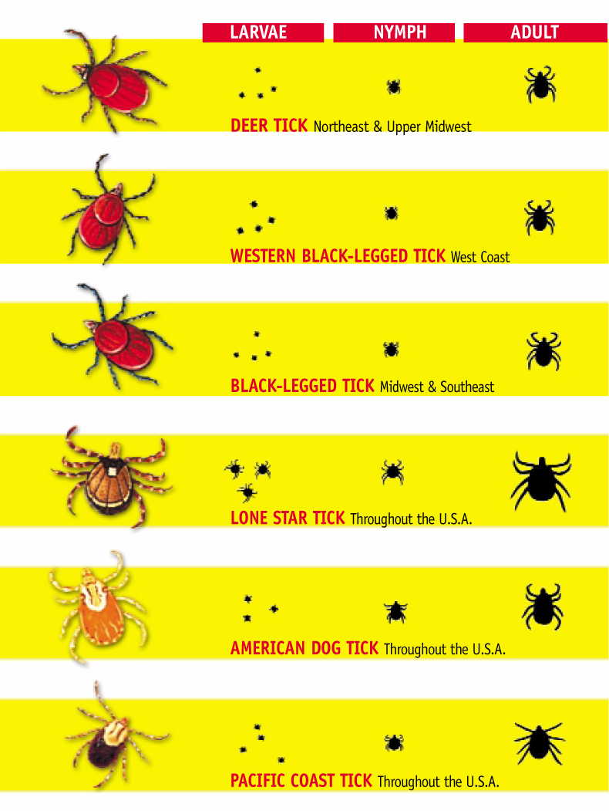

ABOUT LYME:
Lyme disease is typically seen in dogs and people. It can occur in cats, but is rare and the disease process is not clearly understood. So this is for DOG owners!
Lyme disease is a BACTERIAL disease. BACTERIA= B. burgdorferi (so called spirochetes because of their shape)
It is transmitted by DEER ticks ONLY (on the East Coast).
Ticks LOVE MOIST AND WARM client, therefore the most dangerous period is SPRING and FALL. Of course if we have rainy summers or mild winters they continue to be out and dangerous. However, if it is an arid summer or a very cold winter, they go into hiding and remain dormant (sleepy:-)
The DEER TICK ( scientific name=Eastern black-legged tick (Ixodes scapularis)) and the Western black-legged tick (Ixodes pacificus)the are the only two tick species in North America that have been proved to pass the infection to dogs and humans.
Ticks don't attach to animals and humans to transmit the infection. They attach to get a blood meal which is essential to their reproduction.
Both dogs AND humans get LYME disease, IF the attached tick is infected. You and your dog can become infected from single or multiple tick bites from infected ticks.
They (dogs and humans) CANNOT pass infection to each other!
80% or more of deer ticks in our area (Connecticut, USA) are infected, so the chances are high. In addition, each female tick can deposit thousands of eggs and if she is positive, she can pass the disease to her offsprings!
The DEER tick is a three-host tick, which means it feed on animals (white-footed mouse, deer and dogs/humans) throughout tick's life cycle—as larvae, nymphs, and adults.

The tick HAS to attach and feed on your or your dog's blood for 24-48 hours, BEFORE it can pass Lyme disease on to your dog or you.

This is critical! Since: if you notice an tick within 24 hours and REMOVE it WITH IT"S HEAD attached- you or your dog are NOT going to be infected by THAT tick. Of course if you missed another tick somewhere, you or your dog can get infection.

The bacteria sits in tick's mouth parts (salivary glands) and are released into the blood stream of either human or dogs AFTER 24 hour period, when the tick ingested enough blood and "burps"! These few bacteria then travel to their "favorite spot" so they can grow and flourish/thrive. In dogs: those are joints and kidneys. In humans: central nervous system and joints. That is why dogs and humans often have different symptoms. Dogs become arthritic and develop kidney failure if not caught in time and people develop central nervous system signs (EARLY: flu-like symptoms, headache, chills, muscle/joint pain, swollen glands, unusual tiredness, loss of appetite. LATER: vertigo, facial paralysis, loss of reflexes, memory problems, spinal cord, brain inflammation and behavioral changes).

In dogs: initially there are mild or no signs and you might not even notice anything. When Lyme progresses 96% of dogs might still show NO signs, others develop fever, enlarged lymph nodes, depression, and lethargy, as well as shifting lameness and swollen joints. Some might develop progressive severe kidney disease, especially such genetically sensitive breeds, as Golden Retrievers, Labradors and Shelties.

****In humans: there is a research that suggests if an ADULT, I repeat ADULT HUMAN, takes 200mg of Doxycycline on the day of the bite (i.e.within 24 hours of the tick attaching), he/she will completely eliminate Lyme disease that was transmitted by ticks attached during that 24 hour period. DISCLAIMER: This is NOT a MEDICAL ADVICE and YOU SHOULD CONSULT YOUR PHYSICIAN regarding any matters related to HUMAN HEALTH!

That is why PREVENTION in a form of a REPELLANT is a KEY!

If you don't get a tick attached, there is no way a tick can transmit a disease!

TESTING: Unlike in humans, we have a great test that can detect whether your dog is infected and how severely! Remember, that if your dog has a recent infection (within 4-6 weeks), it might NOT show up POSITIVE. In addition, this "Lyme test" also tests for 3-4 other tick-borne diseases AND HEARTWORM TEST!, so YOU DON'T HAVE TO do the HEARTWORM TEST AGAIN as a separate test, hence save some $$.

PREVENTION:

Tick preventives that are highly effective acaricides with residual effects on ticks are strongly recommended for all dogs year-round everywhere. It is also recommended to remove ticks as quickly as possible from dogs with forceps or special tick removal devices.Take care to avoid contact with tick contents by wearing gloves to prevent zoonotic infections. And wash your hands thoroughly and regularly.
1) My favorite is PREVENTIC COLLAR- it is TICK REPELLANT! (unlike Frontline). This means that ticks might get on the dog, but will NOT attach!
ADVANTAGE- very effective tick repellant
lasts 3 months
DISADVANTAGE- doesn't protect against fleas. I personally am not so concerned about fleas in our area… but it could be a nuisance…
*** I have only seen it fail twice: in one case the collar was very loose and in another case the dog had long thick hair...
2) Frontline Plus- flea and tick PREVENTATIVE. This means that ticks will HAVE TO ATTACH in order to ingest Frontline and then hopefully fall off before they are able to transmit the disease, but that doesn't happen all the time.
ADVANTAGE- prevents fleas as well
DISADVANTAGE- NOT 100% effective, especially towards the end of the application cycle.
3) Remove ticks ASAP when detected: there are a few techniques and all are contradictory to each other… So this is what works for me:
a) apply alcohol or small amount of oil over the attached tick to "suffocate" it;
b) pull gently by twisting it very slightly clockwise. It is very important to remove tick's head (which is embedded into the skin), because Lyme bacteria sit in the mouthparts of a tick and by leaving the head in, the tick still might be able to release bacteria into the blood stream of a human or the animal, even if you removed the tick's body…
c) if not submitting to testing, dispose of a tick by flashing it in a piece of a toilet paper. They are very quick and have a "dead grip":-)
d) make sure you don't have any abrasions or cuts on your hands before dealing with tick removal, since you can get infected through the cut in your skin. Don't squeeze the tick, so it doesn't rupture in your hand. Wash your hands well after.
4) Environmental control: mown the lawn regularly, avoid tall grassy and woody areas.
Humans: wear light-colored, protective clothing; use repellant products labeled specifically for effectiveness against ticks; check yourself and family members, especially children for ticks daily; and remove ticks as quickly as possible.

TICK TESTING: in Greenwich, you can bring the tick you removed from either a human or your pet to the Town Hall Lab and they will check the tick/ticks for infection for a small fee. This is a good option to have peace of mind.

LYME VACCINE: There are two camps among veterinarians: believers and non-believers. I don't believe in Lyme vaccine and DO NOT RECOMMEND IT! Here is why:
a) NOT 100% effective. Many dogs that I have seen being vaccinated, still came down with Lyme disease!
b) DOESN"T protect against current infection, but claims, that "may protect" against future infections.
c) possible post-vaccine Lyme disease like symptoms- joint pain, soreness and kidney inflammation (glomerulonephritis). It is thought that this vaccine can also predispose dogs to immune-mediated diseases.

Of course if you live in the middle of the woods or if you spend your days hunting and browsing through nature preserves, then maybe Lyme vaccine will be a good idea for your dog!

Hope that helps and get your PREVENTIC COLLAR! Of course, if your dog NEVER touches the ground or is allergic or barely goes out, then you DON'T need to worry tick prevention!:-)

