1. Which pictures describe your cat’s life? (circle all that apply)

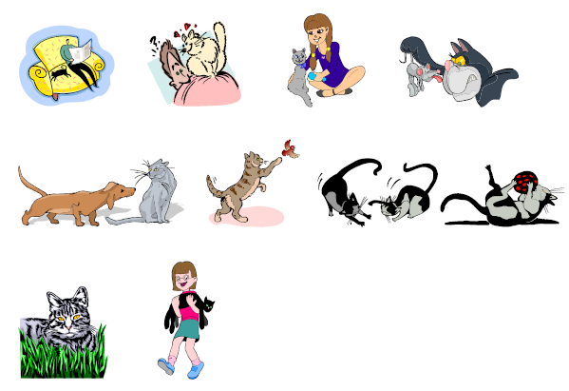

2. Which picture is most like your cat? (circle one)

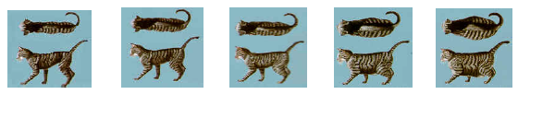

3. What is your pet’s age in human years?
